C++ Basics
We are going to start by typing our header file which is: -
#include <iostream>
Now we need a Main function. Main function is where the program begins we will type: -
Int main () {
}
In curly braces we type our code inside of it and the program will read from top to the bottom of our code. At the end of curly braces, we will type return 0; if we reach return 0 that means that there were no problems in this program, however if 1 is returned that means that there was a problem.
int main() {

return 0;
}
And to display our first code we need to type: -
Std::cout << “I Like Burger”;
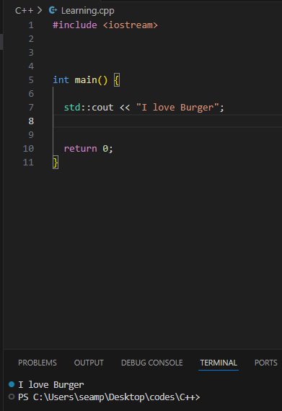
Let’s display something else.
Std::cout << “I hate my life”;
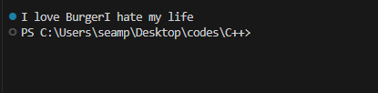
After running the code, we run into a problem that the there is no line between the two statements and the way to separate them is to type the following: -
Syntax: endl; = Stands for new line or end of the line and it separates between two statements.
Std::cout “I love Burger” << std::endl;
Std::cout “I hate my life” << std::endl;
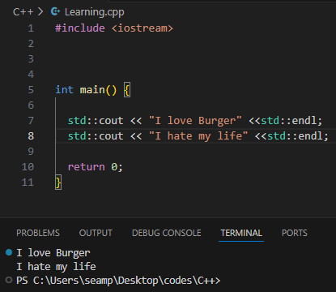

Another option for a new line that’s better performance is to add a new line character.
Syntax: ‘\n’
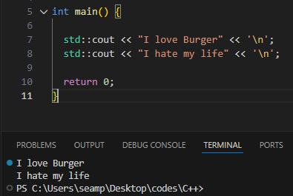
Adding a new line character “\n” does the same thing with end line “endl” and its better performance wise however the benefit of using end line is that end line will flush the output buffer, you can use either one.
Variables
A variable is a representation of some number or value. There are two steps of creating and using a variable: -
Declaration
Assignment
We will begin with declaration. To declare a variable, we need to list the data type of what we are trying to store. To store a whole number, we type int or Integer, then we need a unique identifier for this variable let’s say Jo.
Int jo; = This step is called declaration
Now to assign a variable you take the variable unique identifier or name then we will type equal (=) and some number let’s say 13.
Jo = 13;
Then to display a variable we type: -
Std:: cout << jo;
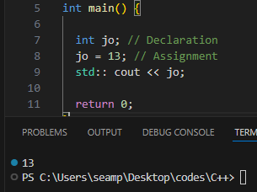
We can combine both in one code.
int jo = 13;
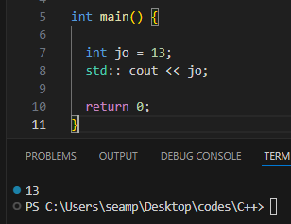
Int jo = 13;
Int je = 19;
Int sum = jo + je;
We can do addition, subtraction and multiplication with these variables just like we added 13 and 19 and that equals 32.

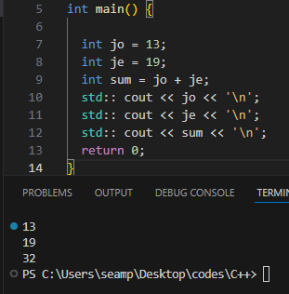
If you want to store a number with decimal portions like 13.5, you can’t use integer for it because it only stores whole number. The only way to store a number with decimal portions is to use a different data type which is: -
Syntax: double
Let’s say you bought something from grocery store and the price is 13.5$ you can just type int price 13.5;
Instead, you type this: -
Double price = 13.5;
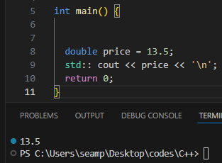
It stored and displayed the number with a decimal.

Now we need to display a character for example a passing grade of A, we use a new data type which is: -
Syntax: char
Note: Char only store single character only something like A,B or even @ and %, but you can store and display a name like John or vanessa that is string.
Char grade = ‘A’;
std:: cout << "Your passing grade is: " << grade << '\n';
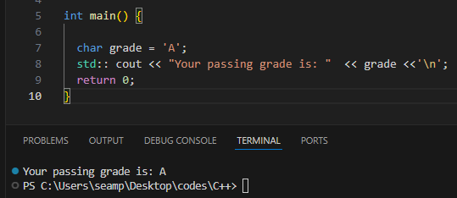
Next is Booleans. A variable that is Boolean only has two states either true or false, and to create a Boolean we use this data type: -
Syntax: bool
Think of it like a light switch, it can be on and off and Booleans work like that as an example let’s say a person is in the hospital and he is either dead or alive in the hospital data base, if it’s true that person is dead and if it’s false that person is alive.
Note: in Boolean 1 is true and 0 is false, you can use numbers instead of true or false.
bool dead = true;
std:: cout << "The status of the patient is: " << dead << '\n';
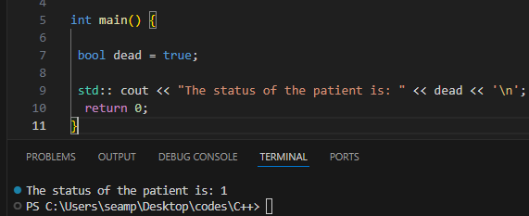
Our last data type is String and string is an object that represents a sequence of text, think of as the char data type but we can store more than two characters like a name.
Strings are provided from the standard namespace. To declare a string, we type:
Syntax: std:: string
Std:: string name = “James”;
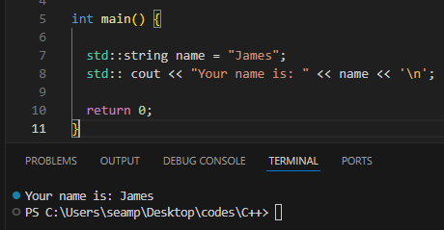
Const Keyword
The const keyword specifies that a variable’s value is constant and tells the compiler to prevent anything from modifying it. Example: -
Double pi = 3.14159;
Double radius = 25;
Double circumference = 2 * pi * radius; = we are multiplying pi and radius to 2.
Std:: cout << circumference << “cm” << ‘\n’;
Output: 157.079cm
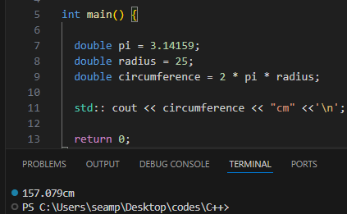
Any variable we do not want be able to be changed at all we can turn it into a constant.
Let’s say somebody goes into our program and wants to change the value of pi to a different number. This will change the result of our circumference which was 157.079 to something else.
Just add the keyword “const” before the variable so it won’t be changed later.
Const Double pi = 3.14159;
Namespace
Namespace provides a solution for preventing name conflicts in large projects. Each entity needs unique name. A namespace allows for identically named entities as long as the namespaces are different.
Suppose we have variable X and X equals 0, each variable needs a unique name and you can’t create another variable and name its X and just give it a value of 1. If you compile this you will run into an error, but if we used namespaces then two or more entities can share a name.
Example : -
To create a namespace, we have to make out outside of the main function, after typing namespace you assign it with a name like first and after you do that you can type int x = 1;.
We have two value of X the first one is withing namespace and has the value of 1 and the second one is in the main function and has the value of 0. After compilation it will run fine. But it will display the local one which is the with the value 0.
#include <iostream>
Namespace first {
Int x = 1;
}
Int main () {
Int x = 0;
std:: cout << x << '\n';
}

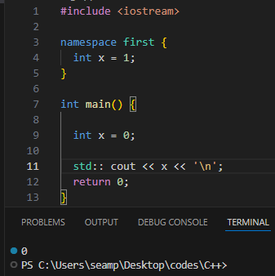
If you do not explicitly state what namespace you are using it will always display the local one and in order to display an X with the value 1 you need to type this : -
std:: cout << first:: x << '\n';
the two colons are know as the scope resolution operator which mean that you are referring to the version of X that is found within the first namespace. You are simply saying display whatever the value of X is, in the namespace First.
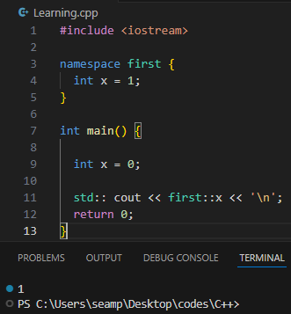
We can simply add and use more name spaces at the same time. Look at the picture below: -
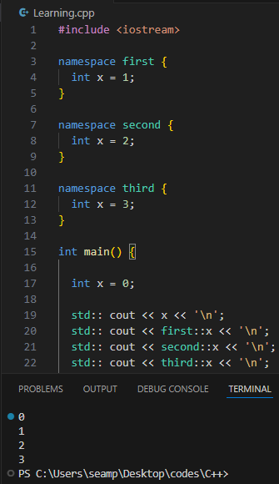
One line you may see is using namespace then a name of the namespace. Example: -
using namespace first;
std:: cout << x << '\n';
If we have some entity without a prefix of the namespace it is assumed that we are using the entity found withing in that particular namespace. If you wanted to display the value of X while using “using namespace first;” it will display the value of X which is 1.

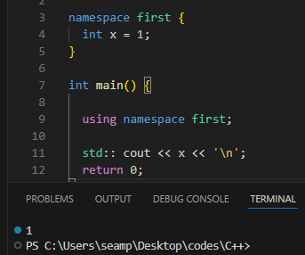
There is a line that the people use and it is : using namespace std; and the reason people include this line is to save a little pit of typing. If we are using “using namespace std” we don’t need to include that prefix std:: to declare strings or to display and output with cout. It will still compile and run, however the standard namespace “std” has hundreds of different entities. One alternative is that we could say “using std::cout;” and that will cut down some repetitions. Or “using std::string;” it is a safer alternative to using namespace standard.
Conclusion
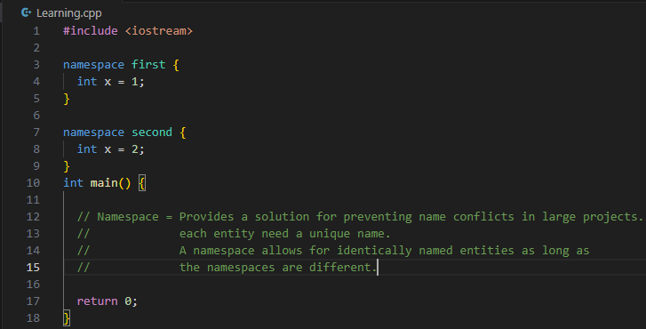

Typedef Keyword
Typedef is a reserved keyword used to create an additional name (alias) for another data type.
New identifier for an existing type helps with readability and reduced typos. Example: -
We need to include this header file: -
#include <vector>
Let’s suppose we have this very long data type and I would like to give it a nickname. We will write typedef then list the original data type.
Typedef std::vector<std::pair<std::string, int>> this is one long data type and it could be for a pair list, but we don’t want to type all of this so, we could do is give this data type an alias or a nickname using this typedef keyword after the original data type we will come up with a new name or a new identifier let’s say pairlist. This is a lot easier to write than all of that. A common convention when using typedef keyword the new identifier usually ends with underscore T ( _T)
And the T stands for type. Suppose I declare a variable of the long data type above and the name is pairlist instead of using the original long data type we use the new identifier which is pairlist_t. example: -
Typedef std::string text_t;
Instead of using std:: string; we could use text_t;
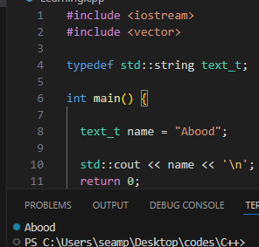
Other examples for a different data type: -

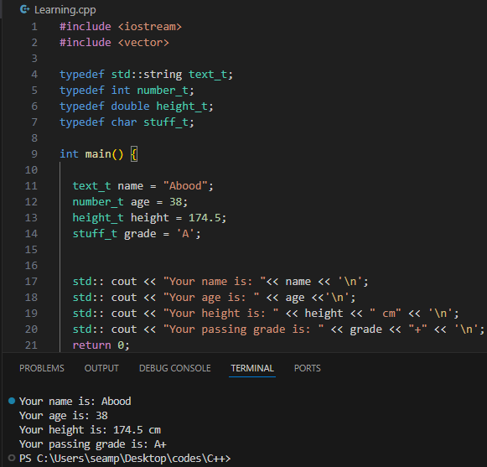
Typedef has largely been replaced by the Using keyword, that’s because the Using keyword works better with templates. So, in place of using typedef I recommend using the “Using keyword”. Example: -
If we where to use the using keyword we would type : “ Using new data type = the old data type;
Using text_t = std::string;
Using number_t = int;
text_t name = "Abood";
number_t age = 105;
std:: cout << "your name is: " << name << '\n';
std:: cout << "your age is: " << age << '\n';

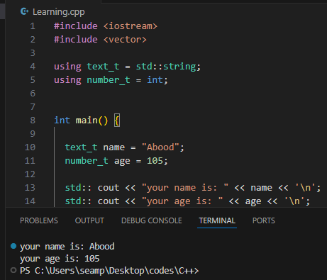
Arithmetic Operators
Arithmetic operators return the result of a specific arithmetic operation ( + - * / ).
Let’s say we have 20 students, if a new student joins our class we would like to add one student. Well, if we are working with variable we could type : -
Int students = 20;
Students = students + 1;
Std :: cout << students;
After we run it we would have 21 in the output. There is a shorter way of writing this too.
In place of saying students = students + 1, we could shorten this into students+=1;
if you want to add one to a variable you could also use the increment operator. Example: -
the preferred way only if you want to add one is: -
students++;
output: 21.
This also works for subtraction, multiplication and division.
Try it out and you will understand more.
Type Conversion
Type conversion is a value of one data type to another.
Two way which we can do this are: -
Implicit = is done automatically.
Explicit = Precedes value with new data type ( int ).
Example: -
Suppose we have variable int x and assign it with the value 5.19, integers can only hold whole numbers. If I where to display X the value that the program will show would be 5 and that’s because we truncated the decimal portion and implicitly the number 5.19 into an integer.
What if X was the double data type and run the program it will display 5.19.
Now let’s move to explicit example which is what would happen if we cast 5.19 as an integer then assign it to a double variable? Example : -
Before the value which was 5.19 add a set of parentheses then the new data type which is int.
We will convert 5.19 to an integer then store it within X.
Double x = (int) 5.19;
Std:: cout << x;
Output: 5.
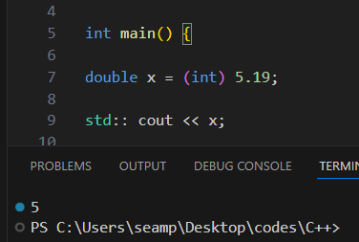

We have a character X the has the value 100 and wanted to display what X was, we will implicitly cast the number 100 as a character which would be after we run the program as D.
Look at the table below to understand.
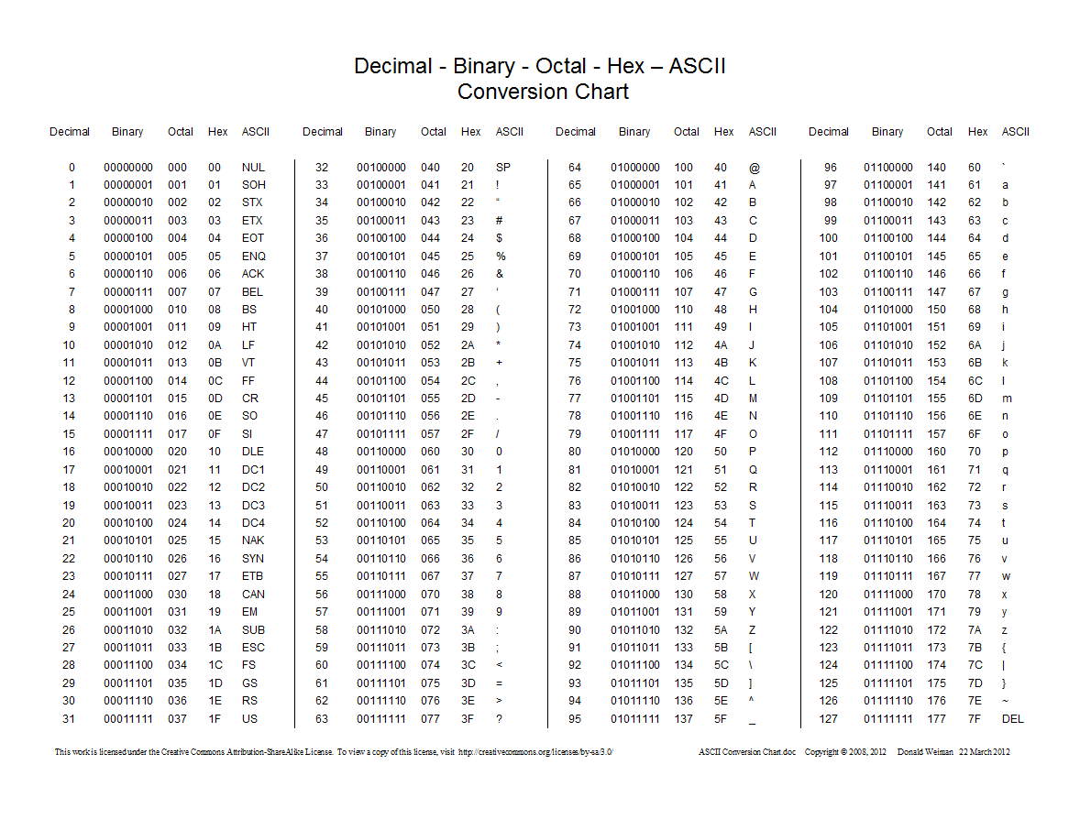
The number 100 converted to character is D.
char x = 100;
std:: cout << x;
Output: d.
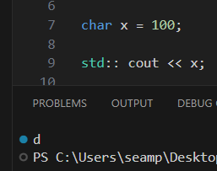
Let’s try explicit cast.
Std:: cout << (char) 100;
Output: d.
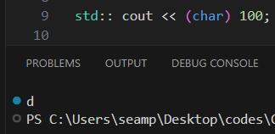
How is this useful? Suppose we have an online exam we have to give the user a score, how many questions did they get right divided by how many questions were total. Let’s write something like this: -
Int correct = 8;
Int questions = 10;
We need to calculate the score as a percentage. We could say: -
double score = correct/questions * 100;
and let’s display whatever the result is.
Std:: cout << score << “%”;
Eight divided by ten is 0.8 multiply it by 100 that should give us 80%.
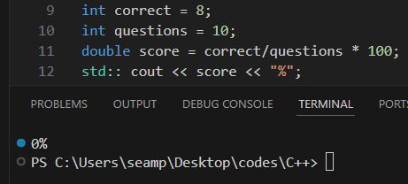
We got 0% and that’s because we are using integer division, questions is of the int data type and when we are dividing 8 by 10 we are truncating that decimal portions or we are getting rid of it, then multiplying whatever remains by 100 and gives us 0%.
To solve this problem, we are going to explicitly cast questions as a double.
Int correct = 8;
Int questions = 10;
double score = correct/(double) questions * 100;
Std:: cout << score << “%”;
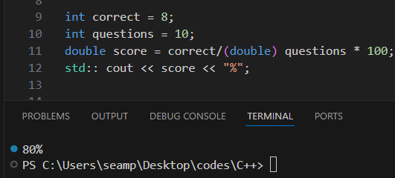
Make something like this maybe with your name or your favorite food.
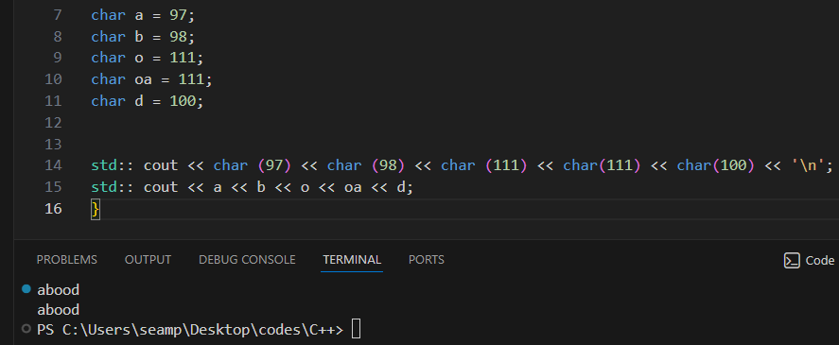

Accepting User Input
We are familiar with cout followed by insertion operator which is two left angle brackets (<<). To accept some input, we would type cin (character input) followed by the extraction operator which is two right angle brackets (>>). Example: - let’s ask for a user’s name and age.
Std:: string name;
Std::cout << “What is your name?: “ << ‘\n’;
Std:: cin >> name;
std:: cout << "Your name is: " << name;
Note: In order to accept user input if you are using Vs Code you need to change program which is the panel at the bottom from output to terminal so you can enter or write something.
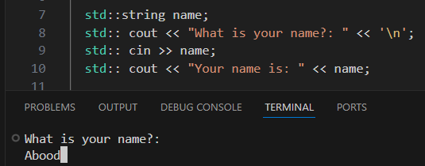
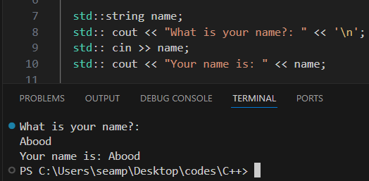

This time let’s ask for the user’s age.
int age;
std:: cout << "What is your age?: " << '\n';
std:: cin >> age;
std:: cout << "Your age is: " << age << '\n';
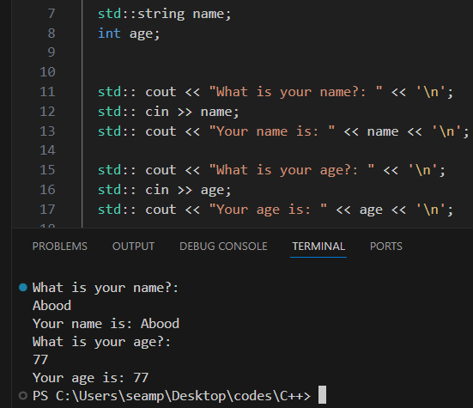
There is a problem though, if you type a string that has spaces something like a full name it has a space after the first name, once we hit space we stop reading that string. Example: -
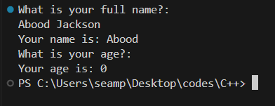
Once we hit space and added both first and last name it stopped reading that string.
To solve this, we will use the function called Getline, it solves this problem for strings.
Std:: string name;
Std::cout << “What is your name?: “ << ‘\n’;
Std:: getline(std::cin, name);
int age;
std:: cout << "What is your age?: " << '\n';
std:: cin >> age;

std:: cout << "Your name is: " << name;
std:: cout << "Your age is: " << age << '\n';
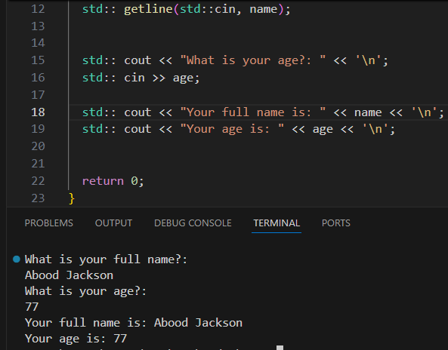
There is one issue with this one, let’s move the second question which is the age question above the name question and after we do that we see that it skipped the second question which was the name and just accepted the first one. Example: -
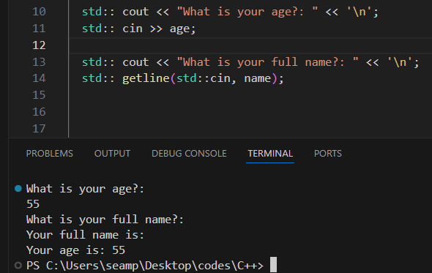
if we accept some user input with cin followed by getline in our input buffer there is a new line character and we do not pick up that new line character when we reach the getline function it accepts the new line character that still within the buffer. To prevent that from happening there is one change we can make to the getline function. After cin two extraction operator (>>) and then add (std::ws). Ws stands for White Spaces.
This portion will eliminate any new line character or white spaces.
std:: cout << "What is your age?: " << '\n';
std:: cin >> age;
std:: cout << "What is your full name?: " << '\n';
std:: getline(std::cin >> std::ws, name);
std:: cout << "Your full name is: " << name << '\n';
std:: cout << "Your age is: " << age << '\n';
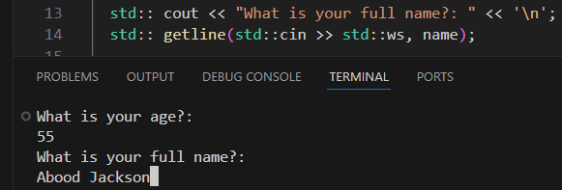
Math Related Functions
There are 8 useful math related functions in C++ that would really be useful when dealing with mathematical. Let’s begin by creating 3 variables.
Double x = 3;
Double y =4;
Double z;
- Max function
The first math related function is the Max function which will return the greater of two values or variables.
z = std::max(x,y);
std::cout << z;
Output: 4.
- Min Function
min function is used to return the minimum of a two values or variables.
Double x = 3;
Double y =4;
Double z;
Z = std::min(x,y);
std::cout << z;
Output: 3.
So, that’s max and min function. The rest of these functions are found the Cmath header file.
Make sure to add #include <cmath> as a header file.
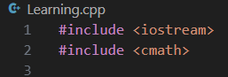

- Pow function
The second math related function is Pow and it’s used to raise base to a given power. Example:-
Double x = 3;
Double y =4;
Double z;
Z = pow(2,3);
Z = pow(2, 4);
std::cout << z;
Output: 8.
Output: 16.
- Sqrt Function (Square Root)
The third math related function is sqrt as know as (square Root).
Double x = 3;
Double y =4;
Double z;
Z = sqrt(9);
std::cout << z;
Output: 3.
- Abs (Absolute Value)
The fourth math related function is abs as known as (Absolute Value). If you place a negative number in the absolute value function it will give the positive version of that number.
Double x = 3;
Double y =4;
Double z;
Z = abs(-3);
std::cout << z;
Output: 3.

- The round function.
The round function is used to round a specific number to the nearest tenth or hundredth or even thousand. If there is a value that is 3.4, and we want to round this number to the nearest hundredth, the answer must be 3.
Double x = 3.4;
Double z;
std::cout << z;
Output: 3.
- Ceiling function
ceil function is used when you want to round up a value.
Z = ceil(x);
Output: 4.
- Floor Function
floor function is used when you want to round down a value.
Double x = 3.9;
Z = floor(x);
Output: 3.
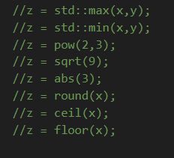
56:03

